**LAB 7: Explanations of BCNF Tables**

For a table to be in BCNF:

It must satisfy 3NF, and for every non-trivial functional dependency, the determinant must be a superkey.

| Primary Key | Foreign Key |
| --- | --- |

Address Table

| Address ID | Street Number | Street Name | City | Province | County | Postal Code |
| --- | --- | --- | --- | --- | --- | --- |

**{Address ID (PK)} →** {Street Number**,** Street Name, City, Province, Country, Postal Code}

**{Country} →** {City, Province, Country, Postal Code}

**{Province} →** {City}

EXPLANATION:

This table is not in 3NF because we have some non-key attributes depending on other non-key attributes (transitive dependencies). In order to make the table to 3NF, there are a couple of methods, but we chose to do the Bernstein algorithm that was shown in class. After removing all the redundancies, decomposing and creating tables that satisfy the 3NF conditions, we would have the following three tables.

Address Table

| Address ID | Street Number | Street Name | County |
| --- | --- | --- | --- |

Country Table

| Country | Province | Postal Code |
| --- | --- | --- |

Province Table

| Province | City |
| --- | --- |

And below we have shown the work done using the Bernstein Algorithm to make the Address table to 3NF.

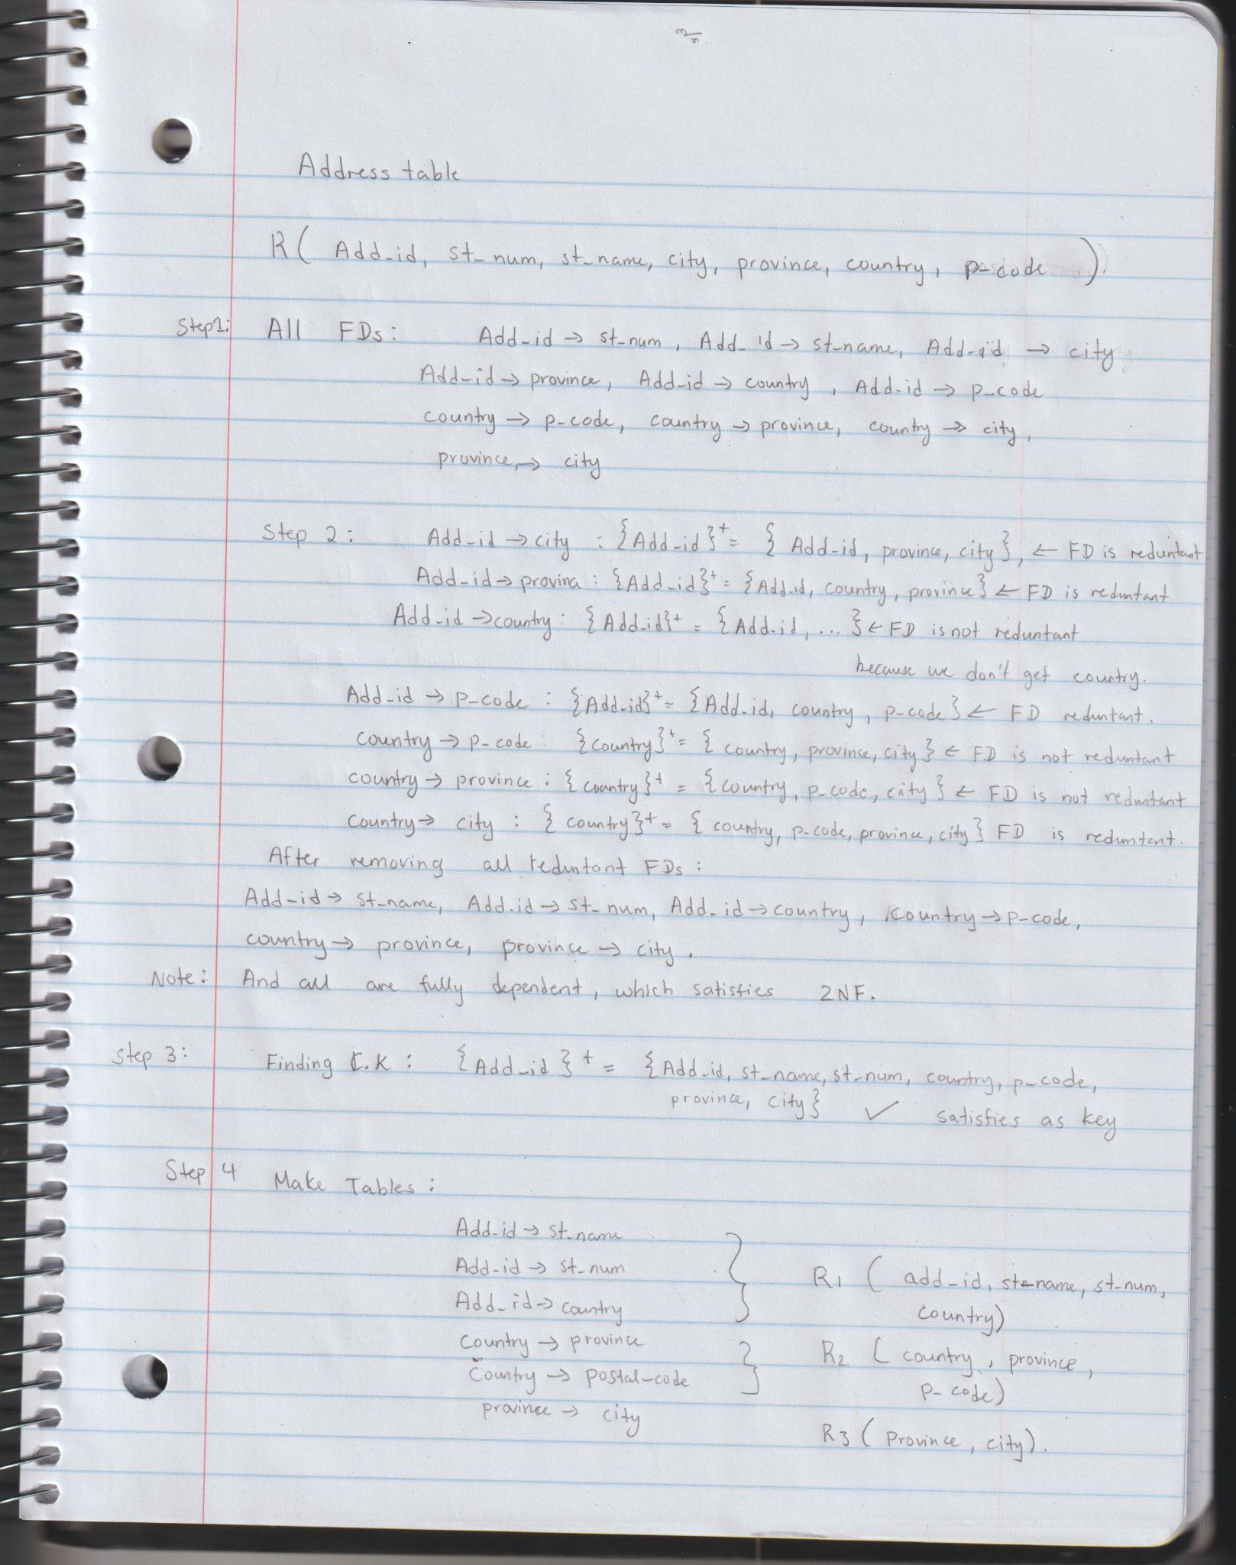

Address Table

| Address ID | Street Number | Street Name | County |
| --- | --- | --- | --- |

**{Address ID (PK)} →** {Street Number**,** Street Name, Country}

EXPLANATION:

This table is in BCNF because along with being in 3NF, the non-trivial functional dependencies all have a determinant of a minimal super key (candidate key). The candidate key for this table is {Address_ID}. This means that there does not exist a functional dependency in which a non-candidate key determines {Address_ID}.

Country Table

| Country | Province | Postal Code |
| --- | --- | --- |

**{Country (PK), Province} →** {Postal Code}

EXPLANATION:

This table is in BCNF because along with being in 3NF, the non-trivial functional dependencies all have a determinant of a minimal super key (candidate key). The candidate key for this table is {Country}. This means that there does not exist a functional dependency in which a non-candidate key determines {Country}.

Province Table

| Province | City |
| --- | --- |

**{Province (PK)} →** {City}

EXPLANATION:

This table is in BCNF because along with being in 3NF, the non-trivial functional dependencies all have a determinant of a minimal super key (candidate key). The candidate key for this table is {Province}. This means that there does not exist a functional dependency in which a non-candidate key determines {Province}.

Customer Table

| Customer ID | Address ID | Username | Password | Email | First Name | Last Name | Phone Number |
| --- | --- | --- | --- | --- | --- | --- | --- |

**{Customer ID (PK)} →** {Username, Password, Email, First Name, Last Name, Phone Number, Address ID}

EXPLANATION:

This table is in BCNF because along with being in 3NF, the non-trivial functional dependencies all have a determinant of a minimal super key (candidate key). The candidate key for this table is {Customer ID}. This means that there does not exist a functional dependency in which a non-candidate key determines {Customer ID}.

Product Table

| Product ID | Product Name | Product Desc | Price | Stock | Image URL |
| --- | --- | --- | --- | --- | --- |

**{Product ID (PK)} →** {Product Name, Product Dec, Price, Stock, Image URL}

EXPLANATION:

This table is in BCNF because along with being in 3NF, the non-trivial functional dependencies all have a determinant of a minimal super key (candidate key). The candidate key for this table is {Product ID}. This means that there does not exist a functional dependency in which a non-candidate key determines {Product ID}.

Category Table

| Category ID | Category Name |
| --- | --- |

**{Category ID (PK)} →** {Category Name}

EXPLANATION:

This table is in BCNF because along with being in 3NF, the non-trivial functional dependencies all have a determinant of a minimal super key (candidate key). The candidate key for this table is {Category ID}. This means that there does not exist a functional dependency in which a non-candidate key determines {Category ID}.

Product Category Table

| Product Category ID | Product ID | Category ID |
| --- | --- | --- |

**{Product Category ID (PK)} →** {Product ID, Category ID}

EXPLANATION:

This table is in BCNF because along with being in 3NF, the non-trivial functional dependencies all have a determinant of a minimal super key (candidate key). The candidate key for this table is {Product Category ID}. This means that there does not exist a functional dependency in which a non-candidate key determines {Product Category ID}.

Order Table

| Order ID | Customer ID | Address ID | Order Date | Order Time | Total Price |
| --- | --- | --- | --- | --- | --- |

**{Order ID (PK)} →** {Customer ID, Address ID, Order Date, Order Time, Total Price}

EXPLANATION:

This table is in BCNF because along with being in 3NF, the non-trivial functional dependencies all have a determinant of a minimal super key (candidate key). The candidate key for this table is {Order ID}. This means that there does not exist a functional dependency in which a non-candidate key determines {Order ID}.

Order Item Table

| Order Item ID | Order ID | Product ID | Quantity | Subtotal |
| --- | --- | --- | --- | --- |

**{Order Item ID (PK)} →** {Order ID, Product ID, Quantity, Subtotal}

EXPLANATION:

This table is in BCNF because along with being in 3NF, the non-trivial functional dependencies all have a determinant of a minimal super key (candidate key). The candidate key for this table is {Order Item ID}. This means that there does not exist a functional dependency in which a non-candidate key determines {Order Item ID}.

Shopping Cart Table

| Customer ID | Creation Time | Creation Date |
| --- | --- | --- |

**{Customer ID (PK)} →** {Creation Time, Creation Date}

EXPLANATION:

This table is in BCNF because along with being in 3NF, the non-trivial functional dependencies all have a determinant of a minimal super key (candidate key). The candidate key for this table is {Customer ID}. This means that there does not exist a functional dependency in which a non-candidate key determines {Customer ID}.

Cart Product Table

| Cart Product ID | Customer ID | Product ID | Quantity |
| --- | --- | --- | --- |

**{Cart Product ID (PK)} →** {Customer ID, Product ID, Quantity}

EXPLANATION:

This table is in BCNF because along with being in 3NF, the non-trivial functional dependencies all have a determinant of a minimal super key (candidate key). The candidate key for this table is {Cart Product ID}. This means that there does not exist a functional dependency in which a non-candidate key determines {Cart Product ID}.